# church_graphicAn ethical framework for making choices in life

### Suggested Bible passages for pre-reading

* Exodus 20:1-17
* Ephesians 5:1-20
* Matthew 5:1-12

### Helpful books to read

* *A Pretty Good Person* by Lewis Smedes
* *Virtue Reborn* by N.T. Wright

### Introduction

Consider these common questions people may face from time to time:

Should I purchase the cheaper item from Asia or the more expensive one from Australia?

Should I ask for a date with this girl or that guy?

How should I deal with my noisy next-door neighbour?

Which political party should I vote for?

Should I say something about what I saw or should I keep quiet?

The Bible gives us clear guidance on some big issues in life (e.g. do not murder, do not commit adultery, etc., but what about all the day to day, week to week, year to year decisions that don’t get a specific reference by chapter and verse? What about the big issues that the people of the ancient world might never have addressed, like medically induced abortion, euthanasia, nuclear energy, space exploration, greenhouse gases, etc.?

This is the concern of normative ethics; it involves the common question,

“What makes something right or wrong?"

We know, of course that in many choices of life, we choose between degrees of good. Some things are a choice between something good and something very good (such as when being offered two jobs after going for interviews). But what about when we have to make decisions about what’s right and what’s wrong? What framework or guidelines might we use to make a decision?

Suspicions about morality abound today. The legal profession has become the butt of jokes about our penchant for relativity and our inability to hold any decent ethical standards in society. Perhaps you’ve heard the story of two partners in a law firm having lunch when suddenly one of them jumped up and said, "I have to go back to the office - I forgot to lock the safe!" The other partner replied, "What are you worried about? We're both here."

Fear not! There is a framework of thinking that can assist us. Let’s bring together the reasoning of ethical theories and the teaching of the bible.

### Ethical Frameworks and the Bible

Professional ethicists commonly identify **three basic paths for deciding what is right and wrong**.

**1. Consequentialist Ethics**: The first path of thinking would argue that x is wrong because it produces harm to someone; or more subtly, it produces more harm overall than benefit. If this is your most common way of determining the answer to ethical questions, then you are what the ethicists may call a **consequentialist**.

This normative theory of ethics says that:

**An action is right if and only if it promotes good consequences.** The most prevalent social and political expression of this theory is utilitarianism, which specifies that **an action is right if it promotes preferred consequences.**

**Q.** Can you think of an example of a utilitarian choice in daily life?

(e.g. I will choose to take my car to work rather than the tram today because it is raining, even though it will stretch our transport budget, because I don’t want my hair-do ruined.)

"Relativity applies to physics, not ethics."

 Albert Einstein

Jeremy Bentham and John Stuart Mil are two prominent ethicists in this area. Peter Singer may also be regarded this way. Another way of thinking about this is as a **harms/benefits analysis**. This seems to make “sense” in many situations, but it sometimes produces odd results, or conclusions which run counter to some of our deepest moral intuitions.

 An assumption in this theory is that **no action is right or wrong in itself**, but is only made so by the **consequences** it promotes. So, in unusual circumstances, killing, lying, stealing, torture, may not only be permissible but preferred (e.g. The U.S. government deemed unusual practices of indefinite detention of alleged terrorists at Guantanamo Bay and torture of same to be “good” because saved American citizens from potential harm). In this ethical theory there can be no such thing as individual “rights” because only the overall benefit counts. It’s simply a matter of doing the sums and maximizing the consequences.

Some ethicists and theologians in the 1960’s (e.g. Fletcher) suggested that the Bible encourages us to ask a simple question, “What is the loving thing to do?” Often called the “Situational ethic theory”, its appeal lies in the love-impelled emphasis. It seems to have a ring of truth to it. We will consider what merits lie within this theory for Christians later in this article.

The first “C” in our framework for ethical choices in life, then, is **Consequences**.

**2. Command Ethics:** Running somewhat counter to consequentialist ethics are the non-consequentialist normative ethical theories that claim there are some acts that should **never** be done, no matter what good consequences they may promise. A classic example is a “rule” common in many societies that **punishment of an innocent person** is wrong.

In consequentialist theory, the only ethical justification for “punishment” and the only way to determine what form it should take is the consequences- no other rule applies. If prevention/deterrence of future crimes is the best outcome achieved by the punishment of, or even execution of an innocent person, then this theory may render such actions entirely justifiable. Similarly, torture can be justified on the basis of prevention of very bad consequences!

We need then to consider the two types of non-consequentialist normative ethical theories:

1. the first is often called **deontological** **ethics** and brings into view commands, rules and laws that govern decision making about what is right or wrong.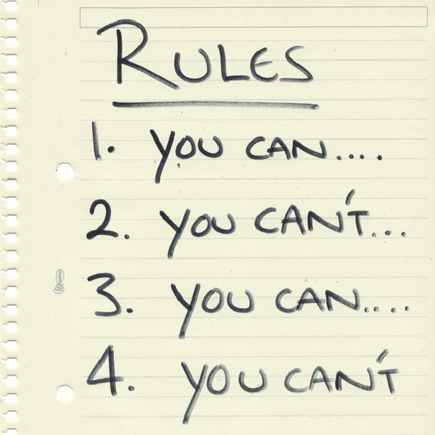 **Deontological** theory (from the Greek word *deon,* meaning obligation or duty) says that **an action is right if it is in accordance with a moral rule or principle.** Such moral rules or principles might be, for example, derived from laws in the Bible or another religious text, natural law, or by way of reason.

"The right to swing my fist ends where the other man's nose begins."

Chief Justice Oliver Wendell Holmes

For example, one contemporary version of deontological theory is associated **human rights movements**. To proclaim a right, such as the right to life, or free speech, or the right to die with dignity and so on, is to invoke a moral rule, to claim that there is a duty to provide, or at least not to interfere with such things.

Rights language is very strong moral language and is inherently at odds with consequential approaches to an issue. By nature, in this theory, one must not violate such and such a right, no matter what the consequences. So, for example if a right to be free from slavery is established, but a whole town’s economy may collapse due to the abolition of slavery, one must follow the rule despite the potential demise of the town’s fiscal needs.

In Australia today, powerful rights language coexists with an apparent emphasis on utilitarian ethics and a penchant for pragmatism in politics, making it difficult to discern what framework is chosen at any given time by community leaders regarding ethical matters.

With the paucity of biblical knowledge and a growing disassociation with Christianity in our nation, there are very few “general moral principles” that ethicists agree on. Some Western liberal secular societies, have at times been accused of **moral bankruptcy** by those who prefer a “rules” based framework for decisions on ethical matters.

Christians consider many commands from God recorded in the Bible as an important basis for decision-making. The Bible does have direct commands to relating to universal ethical issues such as sanctity of life, faithfulness in marriage and more (e.g. read the commandments listed in Exodus 20). Many actions are considered intrinsically right or wrong by virtue of their **harmony or disharmony with the realities of the world as God has made it and intends for it to be**. For example, some Christians believe the current environmental crises could have been avoided if people lived more simple and eco-friendly lives as a sign of trust in God’s providence.

Christians are often encouraged to make ethical decisions by considering **decrees and preferences** as set out by Scripture. No assessment of consequences is sufficient without checking the impact one’s decision might make to God’s “laws”, irrespective of whether the consequences of a decision will be costly to them or others. However, Christians are usually assured that by faith they are guaranteed far better outcomes in an eternal sense (e.g. consider the martyr Stephen in Acts chapter 7 who spoke out about God’s plans in public despite the personal, temporal consequences he faced).

The Bible seems to have a predilection for God-centred wisdom and exposes the folly of self-centred wisdom. For example, in Romans, the Apostle Paul argues that all humans identify with Adam (Genesis 1-3) and are affected by sin. Therefore, he claims, human sinfulness means, among other things, that people cannot always know and do what is right (Rom. 3:10–11; 5:17–19). By nature people are slaves to sin (Rom. 6:17–20). Part of the problem is that the mind has become distorted. It is blinded by the “god of this age” (II Cor. 4:4) and warped by one’s own sinful desires (Rom. 8:5–8). The mind is said to be depraved and actually prone to approve “what ought not to be done” (Rom. 1:28). It needs not merely a one-time regeneration but a continual renewing transformation (Rom. 12:2). An Old Testament proverb is foundational Proverbs 3:5-6.

So this is the second “C” in our framework for making ethical choices is **Commands.** Another way to think of this element of our decision-making framework is **rights** or **rules** that may govern, or greatly influence our choices.

**3. Character Ethics,** or sometimes called VirtueEthics,is another non-consequentialist ethical theory that deserves consideration for a robust framework for making ethical decisions. **Virtue** theory says that: **an action is right if it is what a person with a virtuous character would do in the circumstances.**

**Virtue theory** was a prominent way of doing ethics in the classical Greek era and during the medieval era in the Catholic Church. The theory fell into disrepute during the *Enlightenment* in the early 20th Century, but has enjoyed something of a renaissance since the 1980’s, such as in the writings of philosopher Alasdair MacIntyre. Put simply, the theory says that **there is** **more to the moral life than what a person does or does not do**. One should, according to this theory, also consider what kind of person one ought to be. Christians will find parallels in many sayings of Jesus in the Gospels. Virtue ethics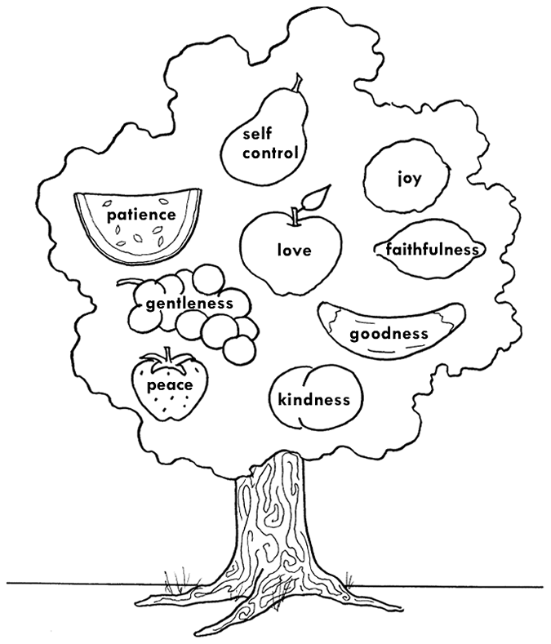 harmonizes well with a Christian decision-making framework if the Christian is confident of God’s promises of sanctification by grace through faith. A new power over sin and self-centeredness, by way of the gift of the Holy Spirit, can help to fashion a new character that leads to different behaviours, according to apostolic teaching (Galatians 5:21-22).

Virtue theory focuses on the development of **good character and the acquisition of virtues** or character traits. It is implied that such traits will then flow on to become “right” or good decisions.

Does this sound familiar to you? Can you recall things Jesus said about character and action? The so-called *beatitudes*(e.g. found in Matthew 5:1-11), commend a series of virtuous traits such as meekness, hunger for righteousness, mercy, purity of heart and more. The teaching of Jesus in chapters 5-7 in the Gospel according to Matthew (often called *The* *Sermon on the Mount*) makes it clear that attitudes of the heart are significant; words and actions reflect what is in the “heart”, whether good or evil.

In another example, Jesus told religious leaders, who put great store in perfect compliance to “rules”, to “…clean the inside first” for “it is from within, from within the human heart, that evil intentions come: fornication, theft, murder, avarice, deceit etc… all these evil things come from within, and they defile a person” (Mark 7: 21-23)

The apostle Paul lists spiritual virtues that are possible in one who has the company of the Holy Spirit (Galatians 5:22,23). He also promotes moral obligations of a virtuous nature for husbands and wives in the early church context (so too for parents and children, masters and slaves).

… on the outside you appear to people as righteous but on the inside you are full of hypocrisy and wickedness.

 Jesus of Nazareth

In today’s society, a parallel might be seen in expectations on doctor/patient and lawyer/client relationships. Such norms might be described in terms of character.

In its pure form, in contrast to other theories, virtue ethics theory suggests that **there is no one right answer for everybody** to an ethical question of what “x” should do to “y”? Rather, **who “x” is**, in what role they are acting, and the nature of relationship between x and y is morally important.

For example, the *Hippocratic Oath* that governs the professional life of most medical doctors did not originally enjoy a broad consensus in classical Greek society. Instead, it was particular convictions of a small group of physicians who agreed to (ironically, it was largely ignored in those times!) tenets that describe the type of professional one should be in terms of relationships, values and virtuous principles (see <http://www.medicinenet.com/script/main/art.asp?articlekey=20909> for an explanation).

Secularism and liberalism have impacted on once virtuous professions. In so many ways, modern professionals have often become more greatly influenced by market forces and profit margins resulting in treating clients as commodities.

The third “C” in a thorough approach to making ethical choices is **Character**. Another term is Virtue Ethics.

### Conclusion

Reading back over the three ethical theories presented thus far Christians will notice that each one on its own seems inadequate for meeting the complex circumstances of life in which our choices are to be made.

For example, the Bible provides substantial “rules” about not killing other people, and yet it does present examples of God’s people being allowed to kill others in some battles. Command Ethics on its own struggles to adequately help us to know whether there are any situations today in which killing might be permissible, even if regrettable. Command Ethics on its own would say, “Never kill”, or “Only kill if...” Consequence Ethics on its own might say, “Kill if it leads to the greater good for the many” (or, at its worst, for “me”). Character ethics adds another important element to the decision-making framework and asks, “What would a ‘good’ or ‘virtuous’ person do?”

In many passages of Scripture we can observe examples of all three ethical theories employed by the writer to guide the reader in making wise choices. For example, looking at a portion of the New Testament *Letter to the Ephesians*, we can highlight sentences that would fit all three of the theories presented in this paper.

Ephesians 5:1-20 is presented below with words suited to any of the three “C’s” f our ethical decision-making theories highlighted in different colours.

* Guidance fit for Consequentialist Ethics is highlighted in red,
* Directions fit for Command Ethics are highlighted in blue, and
* Advice fit for Character Ethics is highlighted in green.

Ephesians 5:1-20

1 Be imitators of God, therefore, as dearly loved children

2 and live a life of love, just as Christ loved us and gave himself up for us as a fragrant offering and sacrifice to God.

3 But among you there must not be even a hint of sexual immorality, or of any kind of impurity, or of greed, because these are improper for God's holy people.

4 Nor should there be obscenity, foolish talk or coarse joking, which are out of place, but rather thanksgiving.

5 For of this you can be sure: No immoral, impure or greedy person-- such a man is an idolater-- has any inheritance in the kingdom of Christ and of God.

6 Let no one deceive you with empty words, for because of such things God's wrath comes on those who are disobedient.

7 Therefore do not be partners with them.

8 For you were once darkness, but now you are light in the Lord. Live as children of light

9 (for the fruit of the light consists in all goodness, righteousness and truth)

10 and find out what pleases the Lord.

11 Have nothing to do with the fruitless deeds of darkness, but rather expose them.

12 For it is shameful even to mention what the disobedient do in secret.

13 But everything exposed by the light becomes visible,

14 for it is light that makes everything visible. This is why it is said: "Wake up, O sleeper, rise from the dead, and Christ will shine on you."

15 Be very careful, then, how you live-- not as unwise but as wise,

16 making the most of every opportunity, because the days are evil.

17 Therefore do not be foolish, but understand what the Lord's will is.

18 Do not get drunk on wine, which leads to debauchery. Instead, be filled with the Spirit.

19 Speak to one another with psalms, hymns and spiritual songs. Sing and make music in your heart to the Lord,

20 always giving thanks to God the Father for everything, in the name of our Lord Jesus Christ.

Using appendix B to this paper, that contains some ethical case studies, enter into discussion using the three “C’s” of the ethical decision-making framework presented above to assist in working out the best choices to be made in the given circumstances.

Rev. Steve Webster April 2015