Viral - All in it together
Acts 14:8-27
Dianne Shay

Intro
Well, that didn’t go as planned did it? We were supposed to be on our way back…
Maybe you thought that 6 weeks from now you might be at home group in person, or even that small numbers might at a worship service.
Instead we’re back in 6 weeks of lockdown with more distancing rules than there were 100 days ago when we began.
Looking at our theme today “All in it together” there are those who might ponder, ‘did we tempt fate?’ Or maybe you thought “have we just had a Careful what you pray for moment?” You know like when you have a trying day having prayed for patience. Did you re-watch the prayers from last week to see if we prayed for solidarity with those in our congregation who’d been put in postcode lockdown, and wail at God “but I didn’t mean you to solve it this way!”
Joking aside, I should point out that God is not capricious. God’s providence and care and mercy show us he walks with us through our trials and challenges.
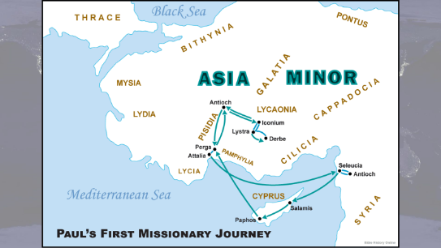
We’re continuing our Good news spreads fast series and there’s a lot in our reading this week that I won’t be able to go into. I hope you’ll take the opportunity during the week to explore these chapters in Acts more closely for yourself – chapters 13 and 14 cover Paul’s first missionary journey and can be read together as a block. Lots of places are mentioned to set the story in its geography so it’s useful to find a map of where the mission team goes.
Back story
We’re picking up the story with Paul and Barnabas in chapter 14 vs 8 in the rural town of Lystra in the region of Lycaonia. They’ve gone there after a strategic exit from Iconium where they were so successful in sharing the gospel and converting both Jews and Greeks that they divided the city and we’re told that “when an attempt was made by both Gentiles and Jews to stone [Paul and Barnabas] the apostles learned of it and fled to Lystra and Derbe where they continued proclaiming the good news.”
Lystra is in a rural area known for growing corn. Previously, when they arrive in a new town Paul and Barnabas go to the local synagogue first to start sharing their good news of Jesus Christ. But here, they go to the town square – it makes sense for a market town, and it also implies there wasn’t a synagogue in Lystra for them to go to.
In the plaza is a man who could not use his feet and had never walked. Paul notices the man is listening as he’s speaking, clearly open to the gospel. Paul says in a loud voice, ‘Stand upright on your feet.’ Paul doesn’t even go over to the man. He just calls out ‘stand upright’. And the man sprang up and began to walk.
Chaos ensues.
Vs 11 When the crowds saw what Paul had done, they shouted in the Lycaonian language, ‘The gods have come down to us in human form!’ 12Barnabas they called Zeus, and Paul they called Hermes, because he was the chief speaker.
Strange as this may seem to us, this is actually a sensible reaction by the people of Lystra. You see, town legend had it that once upon a time Zeus and Hermes had come to earth in disguise. No-one in all the land would give them hospitality until at last two old peasants, Philemon and his wife Baucis (bor-sis), took them in. As punishment for their lack of hospitality the whole population was wiped out by the gods except Philemon and Baucis, who were made the guardians of a splendid temple to Zeus (just outside Lystra). So when Paul healed the man who had never walked the people of Lystra were determined not to make the same mistake again. Take a look at vs 13-17
13The priest of Zeus, whose temple was just outside the city, brought oxen and garlands to the gates; he and the crowds wanted to offer sacrifice.
14When the apostles Barnabas and Paul heard of it, they tore their clothes and rushed out into the crowd, shouting, 15‘Why are you doing this? We are mortals just like you, and we bring you good news, that you should turn from these worthless things to the living God, who made the heaven and the earth and the sea and all that is in them. [he gives] you rains from heaven and fruitful seasons, filling you with food and your hearts with joy.’
In many ways it’s an hilarious scene. The people talking excitedly in the local Lycaonian language that Paul and Barnabas don’t understand. Paul and Barney probably thinking what a cracking job they’ve done sharing the gospel. The priest of Zeus bringing them flowers. And then their horror when they realise that far from giving glory to God, the Lystrans have mistaken them for gods.
We’ve all had those moments haven’t we? Or at least I have. You get them in Sunday school. The lesson where you’re sure the kids totally understood the Trinity, and their parents come to you afterwards and say “why does my child think that God is an egg?”
It didn’t go as planned. the audience had a different starting point for their world view. This passage shows us Paul's approach to those who had no Jewish background to which he could appeal, whose religious views are pantheistic or pagan. We see that Paul starts from nature which they could see and touch and experience in order to help them get to the God who was behind it all. William Barclay phrases it as “He started from the here and now to get to the there and then.”
Paul and Barnabas identify themselves with the people they’re visiting. “We’re not gods”, says Paul. “Turn to the living God, who is not unfamiliar to you because he’s already been caring for you and providing you with all good things.
It feels like that should be the grand finale right. Surely it’s the great point of triumphant conversion.
But Verse 19 immediately tumbles them back into trouble. “Jews came [to Lystra], won over the crowds, stoned Paul and dragged him out of the city, supposing that he was dead. But when the disciples surrounded him, he got up and went into the city. The next day the apostles went on to Derbe.”
The text is ambiguous as to whether the Jews had tracked the apostles to Lystra or simply happened to be there, maybe as corn merchants. Either way the reaction is swift, they argue that Paul (the speaker) deserved to be stoned and he was, severely. (The priest of Zeus probably didn’t take much convincing once he realised Paul was doing him out of a job). We’re not told that Paul died, just that they supposed him to be dead. But when the disciples surrounded him, he got up and went back into the city. That probably freaked out those who had stoned him. Remember the legend, when not recognizing their own gods resulted in all but 2 people being destroyed. Having been determined not to make the same mistake as their ancestors and enraged when Paul proclaimed a different God, they think they’ve killed him and he walks back into town! Who is the God that this man proclaims?
The action then moves on to a quick run-down of the rest of the missionary journey. They went to Derbe and made disciples there, returned to the communities of believers they’d established (including Lystra) to strengthen the souls of the disciples and encourage them to continue in their faith in the face of adversity.
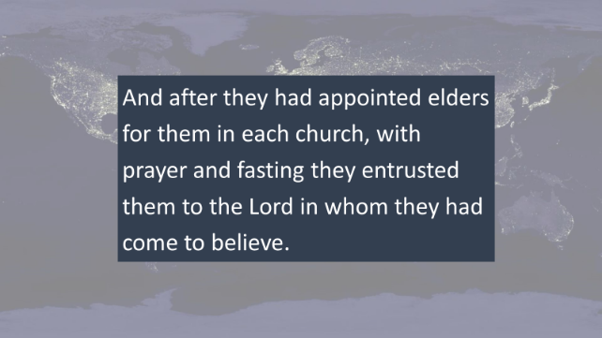
And so we come to a pivot verse. 23. And after they had appointed elders for them in each church, with prayer and fasting they entrusted them to the Lord in whom they had come to believe.
The apostles travel back through places they’ve been, encouraging the faithful and appointing leaders of believing communities to continue the work of proclaiming Christ and building community. They showed their conviction that Christianity is lived in a fellowship. From the very beginning it was Paul's aim not only to make individual Christians but to build these individuals into a Christian fellowship.
Once the apostles made sure the communities are established and have leaders from among them and have entrusted those communities to God, they’ve fulfilled what God had called them to do. Verse 26 they sailed back to Syrian Antioch, where they had been commended to the grace of God for the work that they had completed. They called the church together and related all that God had done to open a door of faith for the Gentiles.
Acts tells us that the church has always understood itself to be ‘all in it together’. Travelling out on the journey Paul is not alone he’s with Barnabas and John Mark. They’re sent out from their base church with support, blessing and prayers. They establish not just believers, but fellowships. They ensure communities are encouraged and strengthened and have leadership to continue. They have been pulled together as God’s people and are All in it together
What about us today
At one level, the idea of us all being in it together is self-evident at a time like this. Christians know encouraging and strengthening each other in faith is essential to our wellbeing as followers of Christ and humans made in God’s image.
At the same time, it would be easy for fellowship to fracture, for other priorities to take over. I admit there’s been a few times where after 8 hours on zoom for work the last thing I’ve wanted is another zoom call for fellowship. But then I find myself being encouraged and strengthened and energised by joining with others virtually. Not such a strange concept when you consider that the New Testament writings are letters, the ancient virtual togetherness.
This passage is of course about more than that. It’s about how we set ourselves up to succeed in fellowship, prayer and worship as a community. How we share our faith with people who don’t know Jesus by starting from their worldview. How we put our faith and trust in the living God who saves (even when things aren’t going as we planned). And that we do all that both as individual believers and as believers together.
Conclusion
When everything changed midweek and all our planning was thrown into disarray, Kim sent me a message to ask did I have a blurb of the topic. I described it as “God calls his followers to work together and support each other in fellowship and has always done so. Right from the time of the early church. It’s a story of miracles, pagans, perseverance, persecution and proclamation with threads of hope, redemption and fulfilment.” Not bad for a story where in the midst of so much going wrong, God is at work to turn hearts to hope and joy; to grow people together as a community through his redeeming grace.
May your soul be strengthened, your faith encouraged knowing we are all in it together, entrusted to the Lord in whom we believe.

